How do you write an essay in a coherent and organized manner?
 |  | This assignment helps you apply your knowledge from this week’s module and textbook readings.
 |  | An essay is an organized collection of paragraphs which contain an introduction paragraph, body paragraphs, and a conclusion paragraph. These different paragraphs build upon each other in a way that allows the reader to learn about ideas in a general way at first and then with more specific detail. Being able to apply the different organizational paragraph structures reviewed here will develop your academic writing skills.
50

The Structure of the Introduction Paragraph
In this section, you will read two versions of an introduction paragraph about the same topic. Read each paragraph carefully and answer the following questions. The diagram below reviews how an introduction paragraph is written. Refer back to Figure 4.2 or Interactive 3A for information on the structure of the introduction paragraph.

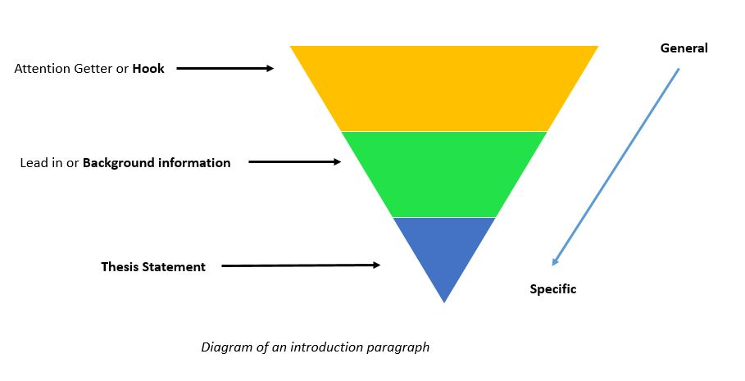

Introduction Paragraph A | Introduction Paragraph B
Teachers are some of the most influential people in a child’s life. When I was in elementary school, Mrs. Greene, my Fourth grade teacher, was that teacher for me. I liked her greatly because she was kind and good at her job. | Children need role models to look up to when they are young. Adults, such as professional athletes or pop stars, are often admired by young people. However, role models are usually people that lead extraordinary lives in local communities. My Fourth grade teacher, Mrs. Greene, was a role model to me because she gave me a love of books, tutored me and other students after school, and spent time fundraising so our school could afford to go on field trips every year.


It is important to remember that UMA has a Scholastic Honesty policy regarding plagiarism. For a
reminder on what plagiarism is, click HERE.

- Identify the introduction paragraph that you think would receive a higher grade from your instructor and explain why it is the better version. Be sure to include specific examples in order to support your answer.   
Type answer here

- Identify the three main points mentioned in the thesis statement of the stronger paragraph


a. Type answer here
b. Type answer here
c. Type answer here

Reviewing the Thesis Statement (Chapter 3, Interactive 3A)
Writing a very clear and specifically worded thesis statement helps the reader understand exactly what your paper is going to discuss about your topic. Refer back to Chapter 3 or Interactive 3B for a more in depth explanation of the thesis statement.

Directions: Read each thesis statement carefully and revise each one to have three (3) specific points.

Example
Before: Technology helps people in many ways.

After: Technology has improved lives through advances in medicine, by giving more people access
to education, and by creating more innovative job opportunities.

- The Allied Healthcare field is a good career choice.  

Type answer here

- My home state is a great vacation destination.

Type answer here

- UMA is an excellent school. 

Type answer here

- I cannot do schoolwork without internet.
Click or tap here to enter text.

Body Paragraph
In this week, the body paragraph was presented as a paragraph in an essay that explains a point in the thesis statement in order to describe a topic in specific detail. A good body paragraph always contains a topic sentence, supporting sentences, and a concluding sentence. Refer back to Interactive 3B for information on writing the body paragraph. You can also review the diagram below in order to review the structure of a body paragraph.

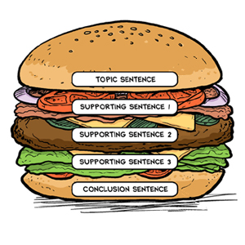
In the example below, all sentences in red represent the supporting details that help to make the paragraph stronger.

Example:

Getting a laptop has improved my student experience at UMA. To start, I am able to have better visibility of my online courses. For example, the larger screen makes it easier to read my assignments and emails. Second, I have more research opportunities with a laptop. To be specific, a laptop has more memory which allows me to download e-books, articles, and navigate the library’s website better than on a smartphone. Lastly, having a laptop makes it easier to complete my homework assignments. For instance, when I have to write an essay in one of my English classes, it is much easier to type on the keyboard and review what I have written. To sum up, my laptop has enhanced my student experience at UMA.

Directions: Read each paragraph carefully and write a supporting detail which includes a specific example. You may use your own ideas to help you.

It is important to remember that UMA has a Scholastic Honesty policy regarding plagiarism.
For a reminder on what plagiarism is, click HERE.

- New York City is a great city to visit on vacation. First, it has many attractions. [7a. Supporting detail]. Second, transportation to travel around the city is affordable. [7b. Supporting detail]. Last, there are many cultural events to consider. [7c. Supporting detail]. To conclude, New York City is a great destination for a holiday. 

- Click or tap here to enter text.
- Click or tap here to enter text.
- Click or tap here to enter text.

- Nutrition is a very important part of prenatal care. First, an expectant mother ought to take vitamins. [8a. Supporting detail].Secondly, a pregnant woman should also choose a healthy diet. [8b. Supporting detail]. Finally, a woman expecting a child should stay away from certain kinds of foods [8c. Supporting detail]. In conclusion, the nutritional value of what a woman eats while she is pregnant is very important.

- Click or tap here to enter text.
- Click or tap here to enter text.
- Click or tap here to enter text.

It is important to remember that UMA has a Scholastic Honesty policy regarding plagiarism. For
a reminder on what plagiarism is, click HERE.

Directions: Use the topic sentence and the concluding sentence provided below to create a body
paragraph.

- Topic sentence: Getting enough sleep is an important part of becoming a successful student.


Type answer here

Concluding sentence: Finally, students must prioritize getting enough rest in order to become successful.

- Topic Sentence: Students should use a calendar in order to improve their time management skills.

Type answer here

Concluding Sentence: To sum up, using a calendar will improve the time management skills of students.

The Conclusion Paragraph
As presented in Interactive 3C, the conclusion paragraph wraps up the essay by restating the thesis statement, summarizing the supporting points in one to two sentences, and finishing with final words that connect back to the introduction. You can use the diagram below as a guide to better understand how to write the conclusion paragraph.

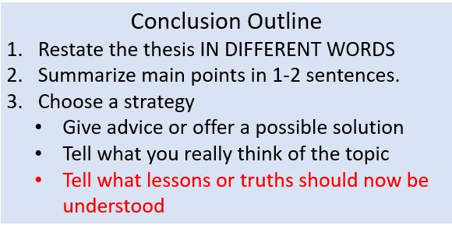

- Directions: Go back to the beginning of this assignment and review the introduction paragraph “B” from #1. Answer the following questions in order to complete the conclusion paragraph below.

Restated Thesis Statement | Instilling in me a love of books, giving private lessons to my classmates and me, and fundraising for school field trips are three reasons why Mrs. Green was a role model to me.
Summarize the main points | Click or tap here to enter text.
What truth or lesson does the writer want the reader to learn about role models by writing about her favorite teacher? (what did the writer state was a misconception about role models?) | Click or tap here to enter text.


Reflection
Reflect on what you have learned this week to help you respond to the question below.
It is important to remember that UMA has a Scholastic Honesty policy regarding
plagiarism. For a reminder on what plagiarism is, click HERE.

- Now that all parts of the essay have been presented step by step, does writing an essay on your own feel more achievable? Why? Or Why not?

Type answer here

